Developing a multivariable risk model integrating urinary cell DNA-methylation & cell-free RNA data for the detection of significant prostate cancer

Shea P. Connell, Rachel Hurst, Martyn Webb, Movember GAP1 Urine Biomarker Consortium, Colin S. Cooper, Antoinette S. Perry, Jeremy Clark, Daniel S. Brewer

# Introduction

This is placeholder text for the introduction - depending on journal this may be considered copyrighted.

# Methods

### Patient population and characteristics

The full Movember GAP1 urine cohort comprises of 1,257 first-catch post-DRE, pre-TRUS biopsy urine samples collected between 2009 and 2015 from urology clinics at multiple sites. Samples within the Movember cohort that were analysed for both methylation and cf-RNA were eligible for selection for model development in the current study (*n* = 207).

Exclusion criteria for model development included a recent prostate biopsy or trans-urethral resection of the prostate (<6 weeks) and metastatic disease (confirmed by a positive bone-scan or PSA >100 ng/mL), resulting in a cohort of 197 samples, deemed the ExoMeth cohort. The samples analysed in the ExoMeth cohort were collected from the Norfolk and Norwich University Hospital (NNUH, Norwich, UK) and St. James’s Hospital (SJH, Dublin, Republic of Ireland). Sample collections and processing were ethically approved in their country of origin: NNUH samples by the East of England REC (*n* = 181), Dublin samples by St. James’s Hospital (*n* = 16).

### Sample Processing and analysis

Urine samples were processed according to the Movember GAP1 standard operating procedure (Supplementary Methods). Hypermethylation at the 5’-regulatory regions of six genes (*GSTP1*, *SFRP2*, *IGFBP3*, *IGFBP7*, *APC* and *PTSG2*) in urinary cell-pellet DNA was assessed using quantitative methylation-specific PCR as described by O’Reilly *et al* (2019). Cell-free mRNA was isolated and quantified from urinary extracellular vesicles using NanoString technology, with 167 gene-probes (Supplementary Table 1), as described in Connell*et al* (2019), with the modification that NanoString data were normalised according to NanoString guidelines using NanoString internal positive controls, and log2 transformed. Clinical variables that were considered are serum PSA, age at sample collection, DRE impression and urine volume collected.

### Statistical Analysis

All analyses, model construction and data preparation were undertaken in R version 3.5.3(1), and unless otherwise stated, utilised base R and default parameters. All data and code required to reproduce these analyses can be found at <https://github.com/UEA-Cancer-Genetics-Lab/ExoMeth>.

#### Feature Selection

In total 177 variables available for prediction (cf-RNA (*n* = 167), methylation (*n* = 6) and clinical variables (*n* = 4). For full list see Supplementary Data), making feature selection a key task for minimising model overfitting and increasing the robustness of trained models. To avoid dataset-specific features being positively selected (2) we implemented a robust feature selection workflow utilising the Boruta algorithm (3) and bootstrap resampling. Boruta is a random forest-based algorithm that iteratively compares feature importance against random predictors, deemed “shadow features”. Features that perform significantly worse compared to the maximally performing shadow feature at each permutation, (*p* ≤ 0.01, calculated by Z-score difference in mean accuracy decrease) are consecutively dropped until only confirmed, stable features remain.

Boruta was applied on 1,000 datasets generated by resampling with replacement, using the training label described below. Features were only positively selected for model construction when confirmed as stable features in ≥ 90% of resampled Boruta runs.

Additional methylation information from four genes (*HOXD3*, *TGF2*, *KLK10* and *TBX15*), was available for a subset of the ExoMeth cohort from previous analyses by Zhao et al (*n* = 144), however these genes did not add additional information in preliminary analysis and were not included in further analyses (data not shown).

#### Comparator Models

To evaluate potential clinical utility, additional models were trained as comparators using subsets of the available variables across the patient population: a clinical standard of care (SoC) model was trained by incorporating age, PSA, T-staging and clinician DRE impression; a model using only the available DNA methylation probes (Methylation, *n* = 6); and a model only using NanoString gene-probe information (NanoString, *n* = 167). The fully integrated ExoMeth model was trained by incorporating information from all of the above variables (*n* = 177). Each set of variables for comparator models were independently selected via the bootstrapped Boruta feature selection process described above to select the most optimal subset of variables possible for each predictive model.

#### Model Construction

All models were trained via the random forest algorithm (4), using the *randomForest* package (5) with default parameters except for: resampling without replacement and 401 trees being grown per model. Risk scores from trained models are presented as the out-of-bag predictions; the aggregated outputs from decision trees within the forest where the sample in question has not been included within the resampled dataset (4). Bootstrap resamples were identical for feature selection and model training for all models and used the same random seed.

Models were trained on a modified continuous label, based by binning on biopsy outcome and constructed as follows: samples were binned on a continuous scale (range 0 – 1) according to Gleason score: where no evidence of cancer on biopsy are scored 0, patients with disease consisting mostly of Gleason 3 are equal to 0.5 and predominantly Gleason 4 (or 5) are assigned to 1. Treating this label as a continuous variable recognises that two patients with the same Gleason scored TRUS-biopsy detected cancer may not share the exact same proportions of tumour pattern, or overall disease burden within their prostate. This scale is solely used for model training and is not represented in any clinical endpoint measurements, or for determining predictive ability and clinical utility.

#### Statistical evaluation of model predictivity

Area Under the Receiver-Operator Characteristic curve (AUC) metrics were produced using the package (6), with confidence intervals calculated via 1,000 stratified bootstrap resamples. Density plots of model risk scores, and all other plots were created using the *ggplot2* package (7). Cumming estimation plots and calculations were produced using the *dabestr* package (8) and 1,000 bootstrap resamples were used to visualise robust effect size estimates of model predictions.

Decision curve analysis (DCA) (9) examined the potential net benefit of using PUR-signatures in the clinic. Standardised net benefit (sNB) was calculated with the *rmda* package (10) and presented throughout our decision curve analyses as it is a more directly interpretable metric compared to net benefit (11). In order to ensure DCA was representative of a more general population, the prevalence of Gleason scores within the ExoMeth cohort were adjusted via bootstrap resampling to match those observed in a population of 219,439 men that were in the control arm of the Cluster Randomised Trial of PSA Testing for Prostate Cancer (CAP) Trial (12), as described in Connell *et al* (2019). Briefly, of the biopsied men within this CAP cohort, 23.6% were Gs 6, 8.7% Gs 7 and 7.1% Gs ≥8, with 60.6% of biopsies showing no evidence of cancer. These ratios were used to perform stratified bootstrap sampling with replacement of the Movember cohort to produce a “new” dataset of 197 samples with risk scores from each comparator model. sNB was then calculated for this resampled dataset, and the process repeated for a total of 1,000 resamples with replacement. The mean sNB for each risk score and the “treat-all” options over all iterations were used to produce the presented figures to account for variance in resampling. Net reduction in biopsies, based on the adoption of models versus the default treatment option of undertaking biopsy in all men with PSA ≥ 4 ng/mL was calculated as:

$Biopsy_{NetReduction}=(NB_{Model}−NB_{All})×\frac{1−Threshold}{Threshold}$

Where the decision threshold (*Threshold*) is determined by accepted patient/clinician risk (9). For example, a clinician may accept up to a 25% perceived risk of cancer before recommending biopsy to a patient, equating to a decision threshold of 0.25.

# Results

### The ExoMeth development cohort

Linked methylation and transcriptomic data were available for 197 patients within the Movember GAP1 cohort, with the majority originating from the NNUH and forming the ExoMeth development cohort (Table 1). The proportion of Gleason ≥7 disease in the ExoMeth cohort was 49%.

**Table 1.** *Characteristics of the ExoMeth development cohort.*

|  |  |  |
| --- | --- | --- |
|  | Biopsy Negative: | Biopsy Positive |
| **Collection Centre:** |  |  |
| NNUH, n (%) | 68 (88) | 113 (94) |
| SJH, n (%) | 9 (12) | 7 (6) |
| **Age:** |  |  |
| minimum | 42.00 | 53.00 |
| median (IQR) | 66.00 (59.00, 71.00) | 69.50 (65.00, 76.00) |
| mean (sd) | 65.70 ± 8.53 | 69.97 ± 7.44 |
| maximum | 82.00 | 86.00 |
| **PSA:** |  |  |
| minimum | 0.20 | 3.60 |
| median (IQR) | 6.70 (4.20, 8.80) | 10.05 (6.90, 18.20) |
| mean (sd) | 7.44 ± 5.59 | 17.50 ± 18.82 |
| maximum | 30.30 | 95.90 |
| **Prostate Size (DRE Estimate):** |  |  |
| Small, n (%) | 14 (18) | 12 (10) |
| Medium, n (%) | 29 (38) | 56 (47) |
| Large, n (%) | 22 (29) | 37 (31) |
| Unknown, n (%) | 12 (16) | 15 (12) |
| **Gleason Score:** |  |  |
| ≥ 8, n (%) | 0 (0) | 31 (26) |
| 0, n (%) | 77 (100) | 0 (0) |
| 3+4, n (%) | 0 (0) | 42 (35) |
| 4+3, n (%) | 0 (0) | 23 (19) |
| 6, n (%) | 0 (0) | 24 (20) |
| **Biopsy_Result** |  |  |
| Biopsy Negative | 77 (100) | 0 (0) |
| Biopsy Positive | 0 (0) | 120 (100) |

### Feature selection and model development

Using a robust feature selection framework four models were produced in total; a standard of care (SoC) model using only clinical information (age and PSA), a model using only methylation data (Methylation, 6 genes), a model using only cf-RNA information (ExoRNA, 12 gene-probes) and the integrated model, deemed ExoMeth (16 variables) (Table 2). The ExoMeth model is a multivariable risk prediction model incorporating clinical, methylation and cf-RNA variables. When the resampling strategy was applied for feature reduction using Boruta, 16 variables were selected for the ExoMeth model. Each of the retained variables were positively selected in every resample and notably included information from clinical, methylation and cf-RNA variables (Figure 1). Full resample-derived Boruta variable importances for the SoC, Methylation and ExoRNA comparator models can be seen in Supplementary Figures 1 – 3, respectively.

In the SoC comparator model only PSA and age were selected as important predictors. All methylation probes were selected as important in both the independent Methylation model and the ExoMeth models (Table 2). 12 NanoString gene-probes were selected for the NanoString model, notably containing both variants of the *ERG* gene-probe and *TMPRSS2/ERG fusion* gene-probe, alongside *PCA3.* All features within the ExoMeth model were also selected in one of the comparator models.

**Table 2.** *Boruta-derived features positively selected for each model. Features are selected for each model by being confirmed as important for predicting biopsy outcome, categorised as a modified ordinal variable (see Methods) by Boruta in ≥ 90% of bootstrap resamples. Variables selected for the fully integrated model (ExoMeth) are in the highlighted column; for example; Age is selected within the SoC model, but not in ExoMeth.*

|  |  |  |  |
| --- | --- | --- | --- |
| SoC | Methylation | ExoRNA | ExoMeth |
| PSA | GSTP1 | AMACR | ERG exons 4-5 |
| Age | APC | ERG exons 4-5 | ERG exons 6-7 |
|  | SFRP2 | ERG exons 6-7 | GJB1 |
|  | IGFBP3 | GJB1 | HOXC6 |
|  | IGFBP7 | HOXC6 | HPN |
|  | PTGS2 | HPN | PCA3 |
|  |  | PCA3 | SNORA20 |
|  |  | PPFIA2 | TIMP4 |
|  |  | RPS10 | TMPRSS2/ERG fusion |
|  |  | SNORA20 | GSTP1 |
|  |  | TIMP4 | APC |
|  |  | TMPRSS2/ERG fusion | SFRP2 |
|  |  |  | IGFBP3 |
|  |  |  | IGFBP7 |
|  |  |  | PTGS2 |
|  |  |  | PSA |

### ExoMeth predictive ability

As ExoMeth Risk Score (range 0-1) increased, the likelihood of high-grade disease being detected on biopsy was significantly greater (Proportional odds ratio = 2.04per 0.1 ExoMeth increase, 95% CI: 1.78 - 2.35; ordinal logistic regression, **Figure 2**). The median ExoMeth risk score was 0.83 for metastatic patients (*n* = 10). These were excluded from model training and can be considered as a positive control. One metastatic sample had a lower than expected ExoMeth score of 0.55: where no methylation was quantified for this sample, which may reflect a technical failure of the sample.

**Table 3.** *AUC of all trained models for detecting outcomes of an initial biopsy for varying clinically significant thresholds. Brackets show 95% confidence intervals of the AUC, calculated from 1,000 stratified bootstrap resamples. Input variables for each model are detailed in Table 1.*

|  |  |  |  |  |
| --- | --- | --- | --- | --- |
| Initial biopsy outcome: | SoC | Methylation | ExoRNA | ExoMeth |
| Gleason ≥4+3: | 0.75 (0.67 - 0.83) | 0.77 (0.69 - 0.85) | 0.74 (0.67 - 0.81) | 0.81 (0.74 - 0.87) |
| Gleason ≥3+4: | 0.73 (0.66 - 0.79) | 0.78 (0.71 - 0.84) | 0.81 (0.75 - 0.87) | 0.89 (0.84 - 0.93) |
| Any Cancer | 0.70 (0.63 - 0.78) | 0.73 (0.66 - 0.79) | 0.86 (0.81 - 0.91) | 0.91 (0.86 - 0.95) |

ExoMeth was superior to all other models, returning an AUC of 0.89 (95% CI: 0.84 - 0.93) for Gleason ≥3+4 and 0.81 (95% CI: 0.74 - 0.87) for Gleason ≥4+3 (**Table 3**).

As revealed by the distributions of risk scores and AUC, ExoMeth achieved a better discrimination of Gleason ≥ 3+4 disease from other outcomes when compared to any of the other models (ExoMeth all p < 0.01 bootstrap test, 1,000 resamples, **Figure 3**). The SoC model, whilst returning respectable AUCs, would misclassify more men with indolent disease as warranting further investigation than all other models (**Figure 3A**), for example, to classify 90% of Gleason 7 men correctly, an SoC risk score of 0.237 would misclassify 65% of men with less significant disease. The methylation comparator model improves upon SoC, by drawing the risk distribution of Gs 6 men into a more pronounced peak but featured a bimodal risk score distribution extending to higher-risk men; almost 50% of men with Gs ≥ 3+4 have risk scores equal to benign patients (**Figure 3B**). The opposite occurred in the NanoString comparator model exhibited a broad bimodal distribution for lower-risk men (**Figure 3C**). This discriminatory ability of the ExoMeth model over all comparators was improved when biopsy outcomes are considered as biopsy negative, Gleason 6 or 3+4, or Gleason ≥4+3 (**Supplementary Figure 4**).

Resampling of ExoMeth predictions via estimation plots allowed for comparisons of mean ExoMeth signatures between groups (1,000 bias-corrected and accelerated bootstrap resamples, Figure 4). The mean ExoMeth differences between patients with no evidence of cancer were: Gleason 6 = 0.22 (95% CI: 0.14 - 0.29), Gleason 3+4 = 0.36 (95% CI: 0.3 - 0.43) and Gleason ≥4+3 = 0.44 (95% CI: 0.37 - 0.51). Notably, there were no differences in ExoMeth risk signatures of patients with a raised PSA but negative for cancer on biopsy and men with no evidence of cancer (mean difference = -0.03 (95% CI: -0.1 - 0.06), **Figure 4**, **Supplementary Figure 5**).

Decision curve analysis examined the net benefit of adopting ExoMeth in a population of patients suspected with prostate cancer and to have a PSA level suitable to trigger biopsy (≥ 4 ng/mL). The biopsy of men based upon their ExoMeth risk score consistently provided a net benefit over current standards of care across all decision thresholds examined and was the most consistent amongst all comparator models across a range of clinically relevant endpoints for biopsy (**Figure 5**). Of the patients with Gs ≥ 7 disease, 95% had an ExoMeth risk score ≥ 0.283. At a decision threshold of 0.25, ExoMeth could result in up to 66% fewer unnecessary biopsies of men presenting with a suspicion of prostate cancer, without missing substantial numbers of men with aggressive disease, whilst if Gleason ≥ 4+3 were considered the threshold of clinical significance, the same decision threshold of 0.25 could save 79% of men from receiving an unnecessary biopsy (**Figure 6**).

# Discussion

This is placeholder text for the Discussion - depending on journal this may be considered copyrighted.

### Funding Sources & Acknowledgements:

This study was possible thanks to the Movember Foundation GAP1 Urine Biomarker project, The Masonic Charitable Foundation, The Bob Champion Cancer Trust, the King family, The Andy Ripley Memorial Fund and the Stephen Hargrave Trust.

The research presented in this paper was carried out on the High Performance Computing Cluster supported by the Research and Specialist Computing Support service at the University of East Anglia

# Figures

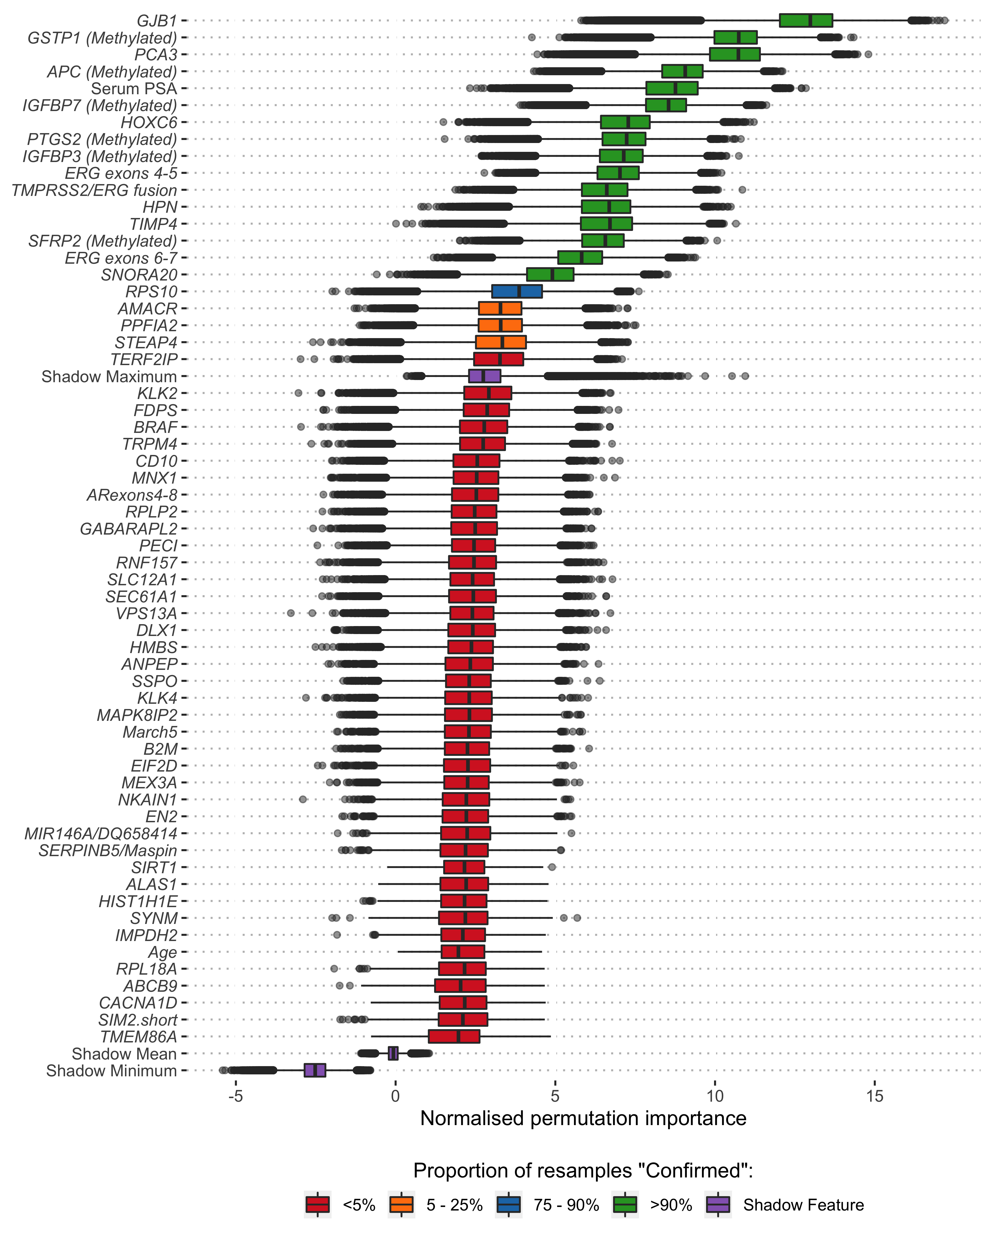

**Figure 1.** *Boruta analysis of variables available for the training of the ExoMeth model. Variable importance was determined over 1,000 bootstrap resamples of the available data and the decision reached recorded at each resample. Colour indicates the proportion of the 1,000 resamples a variable was confirmed to be important in. Variables confirmed in at least 90% of resamples were selected for predictive modelling (Green). Those variables rejected in every single resample are not shown here, but the full list of inputs for all models can be seen in Supplementary Table 1.*

##### 

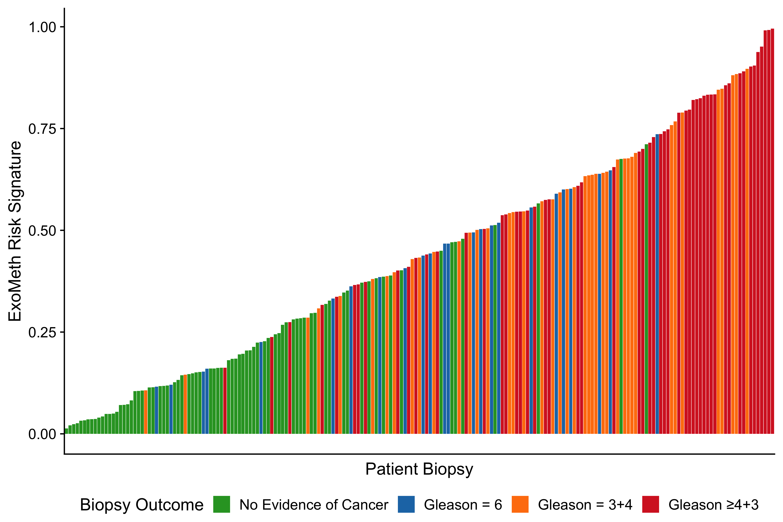

**Figure 2.** *Waterfall plot of the ExoMeth risk score for each patient. Each coloured bar represents an individual patient’s calculated risk score and their true biopsy outcome, coloured according to Gleason score (Gs) . Green - No evidence of cancer, Blue – Gs 6, Orange - Gs 3+4, Red - Gs ≥ 4+3.*

##### 

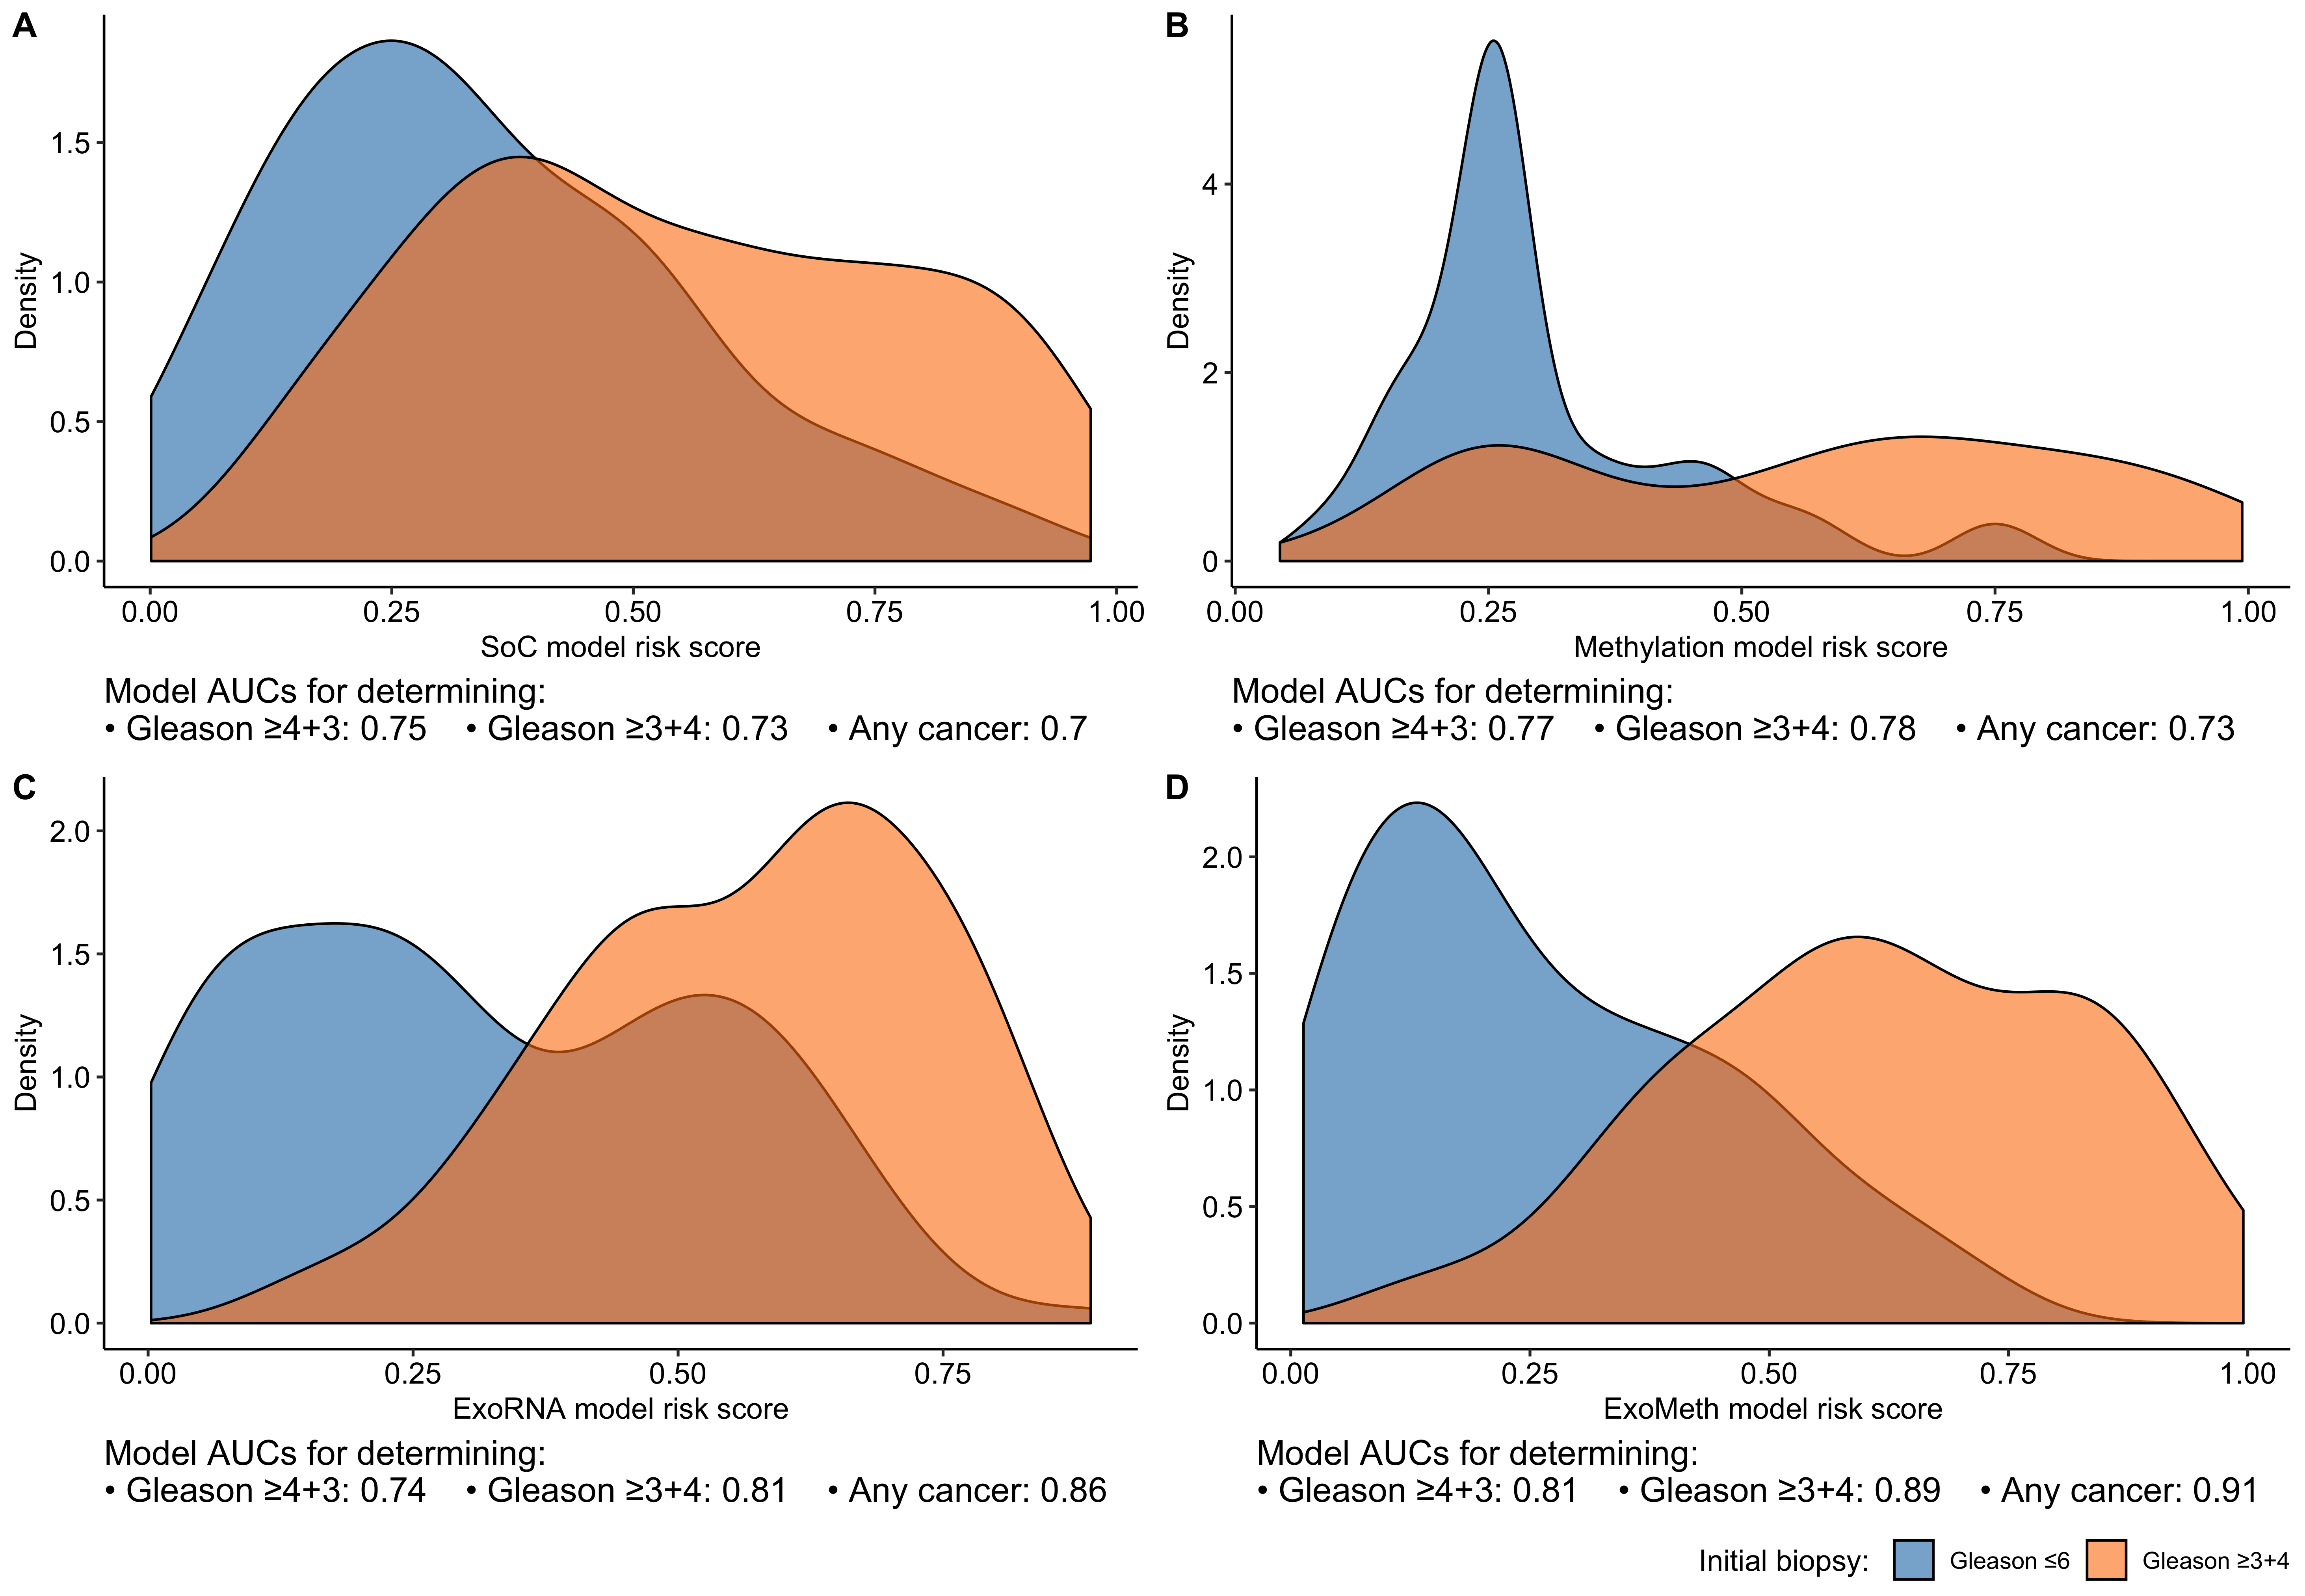

**Figure 3.** *Density plots detailing risk score distributions generated from four trained models. Models A to D were trained with different input variables;* ***A*** *- SoC clinical risk model, including Age and PSA,* ***B*** *- Methylation model,* ***C*** *-ExoRNA model and* ***D*** *- ExoMeth model, combining the predictors from all three previous models. The full list of variables in each model is available in Table 1. Fill colour shows the risk score distribution of patients with a significant biopsy outcome of Gs ≥ 3+4 (Orange) or Gs ≤ 6 (Blue).*

##### 

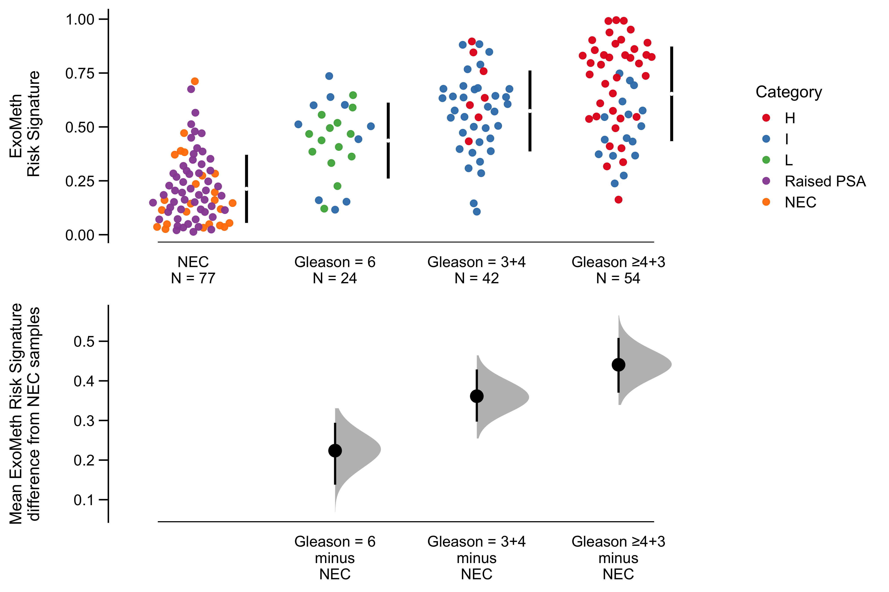

**Figure 4.** *Cumming estimation plot of the ExoMeth risk signature. The top row details individual patients as points, separated according to Gleason score on the x-axis and risk score on the y-axis. Points are coloured according to clinical risk category; NEC - No evidence of cancer, Raised PSA - Raised PSA with negative biopsy, L -D’Amico Low-Risk, I - D’Amico Intermediate Risk, H - D’Amico High-Risk. Gapped vertical lines detail the mean and standard deviation of each group’s risk scores. The lower panel shows the mean differences in risk score of each group, as compared to the NEC samples. Mean differences and 95% confidence interval are displayed as a point estimate and vertical bar respectively, using the sample density distributions calculated from a bias-corrected and accelerated bootstrap analysis from 1,000 resamples.*

##### 

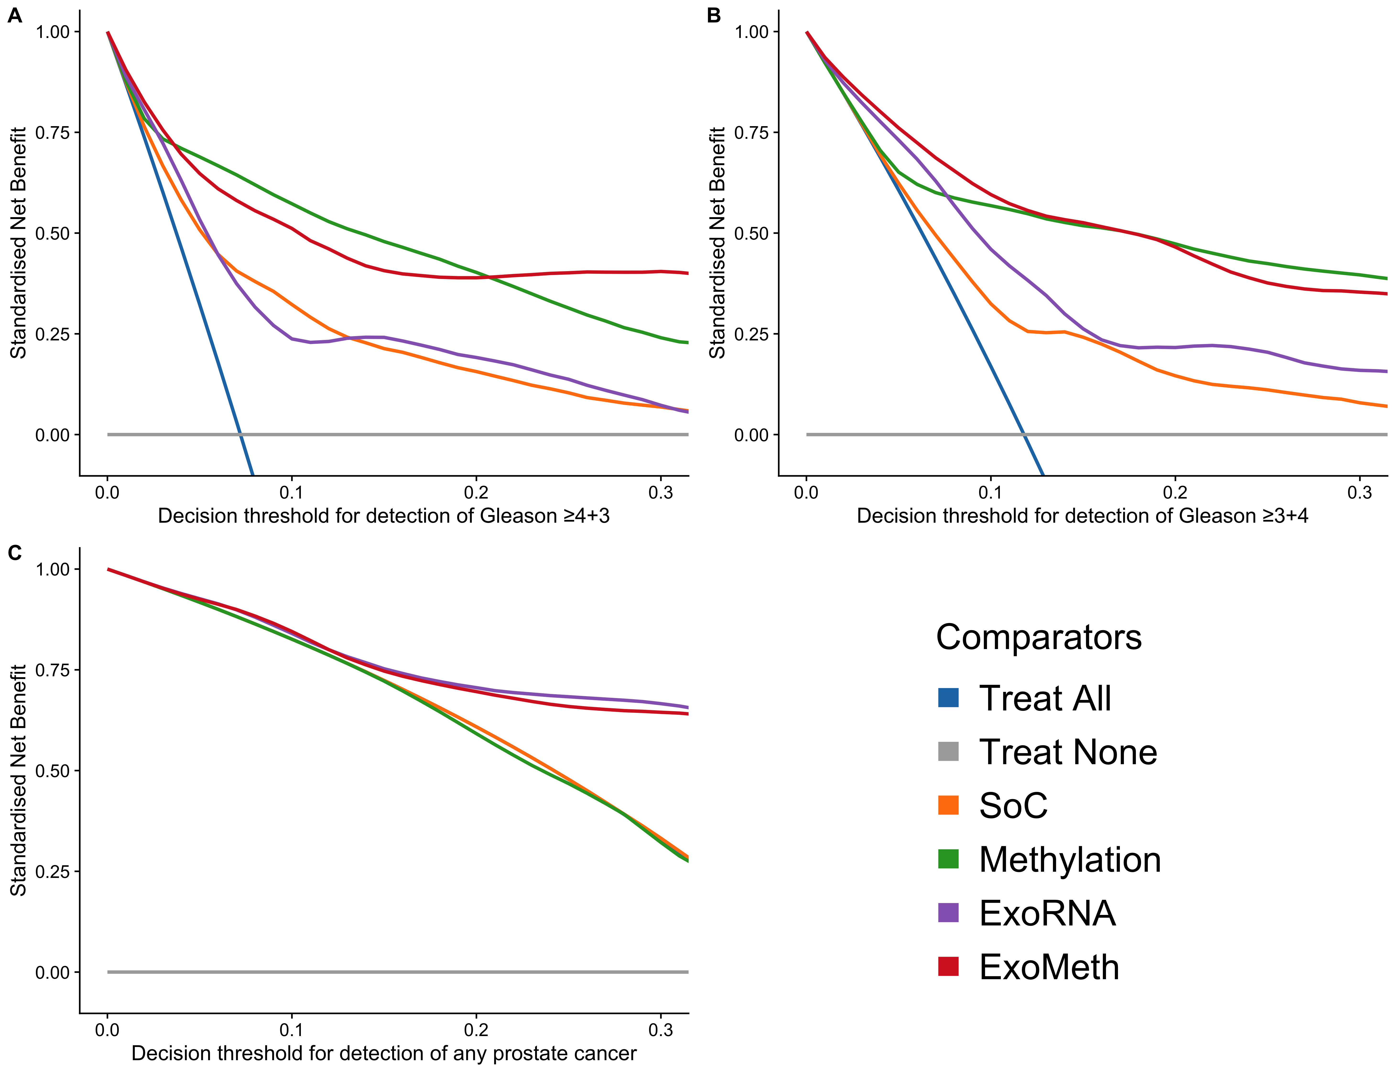

**Figure 5.** *Decision curve analysis (DCA) plots detailing the standardised net benefit (sNB) of adopting different risk models for aiding the decision to biopsy patients who present with a PSA ≥ 4 ng/mL. The x-axis details the range of risk a clinician or patient may accept before deciding to biopsy. Panels show the sNB based upon the detection of varying levels of disease severity:* ***A*** *- detection of Gleason ≥ 4+3,* ***B*** *- detection of Gleason ≥ 3+4,* ***C*** *- any cancer;* ***Blue****- biopsy all patients with a PSA >4 ng/mL,* ***Orange*** *- biopsy patients according to the SoC model,* ***Green*** *- biopsy patients based on the methylation model,* ***Purple*** *- biopsy patients based on the ExoRNA model,* ***Red*** *- biopsy patients based on a the ExoMeth model. To assess the benefit of adopting these risk models in a non-PSA screened population we used data available from the control arm of the CAP study (**13**). DCA curves were calculated from 1,000 bootstrap resamples of the available data to match the distribution of disease reported in the CAP trial population. Mean sNB from these resampled DCA results are plotted here. See Methods for full details.*

##### 

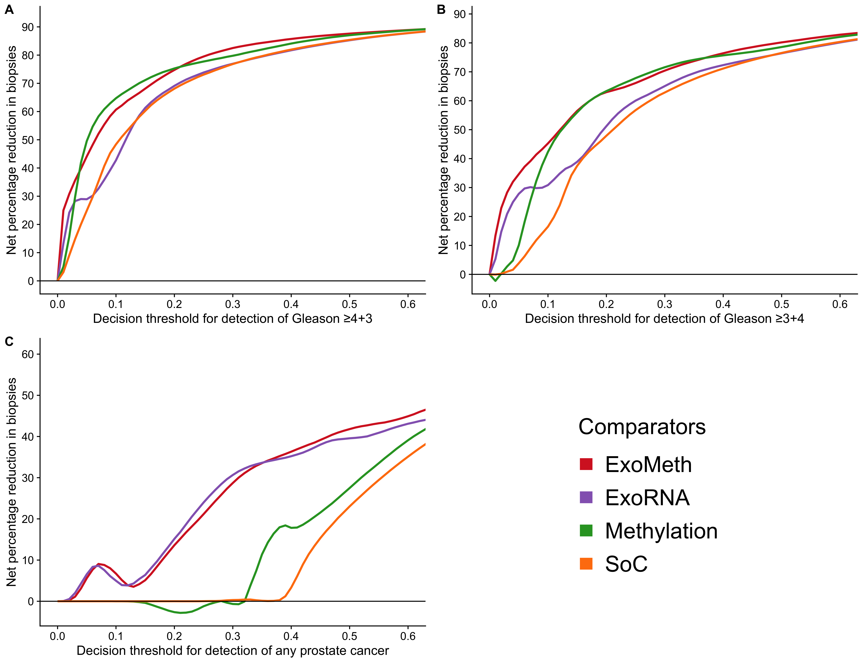

**Figure 6.** *Net percentage reduction in biopsies, as calculated by DCA measuring the benfit of adopting different risk models for aiding the decision to biopsy patients who who would otherwise undergo biopsy by current clinical guidelines. The x-axis details the range of accepted risk a clinician or patient may accept before deciding to biopsy. Panels show the reduction in biopsies per 100 patients based upon the detection of varying levels of disease severity:* ***A*** *- detection of Gleason ≥ 4+3,* ***B*** *- detection of Gleason ≥ 3+4 and* ***C*** *- any cancer. Coloured lines show differing comparator models;* ***Blue****- biopsy all patients with a PSA >3 ng/mL,* ***Orange*** *- biopsy patients by according the to the SoC model,* ***Green*** *- biopsy patients based on the methylation model,* ***Purple*** *- biopsy patients based on the ExoRNA model,* ***Red*** *- biopsy patients based on a the ExoMeth model. To assess the benefit of adopting these risk models in a non-PSA screened population we used data available from the control arm of the CAP study (**13**). DCA curves were calculated from 1,000 bootstrap resamples of the available data to match the distribution of disease reported in the CAP trial population. Mean sNB from these resampled DCA results are used to calculate the potentially reductions in biopsy rates here. See Methods for full details.*

##### 

# Supplementary Material

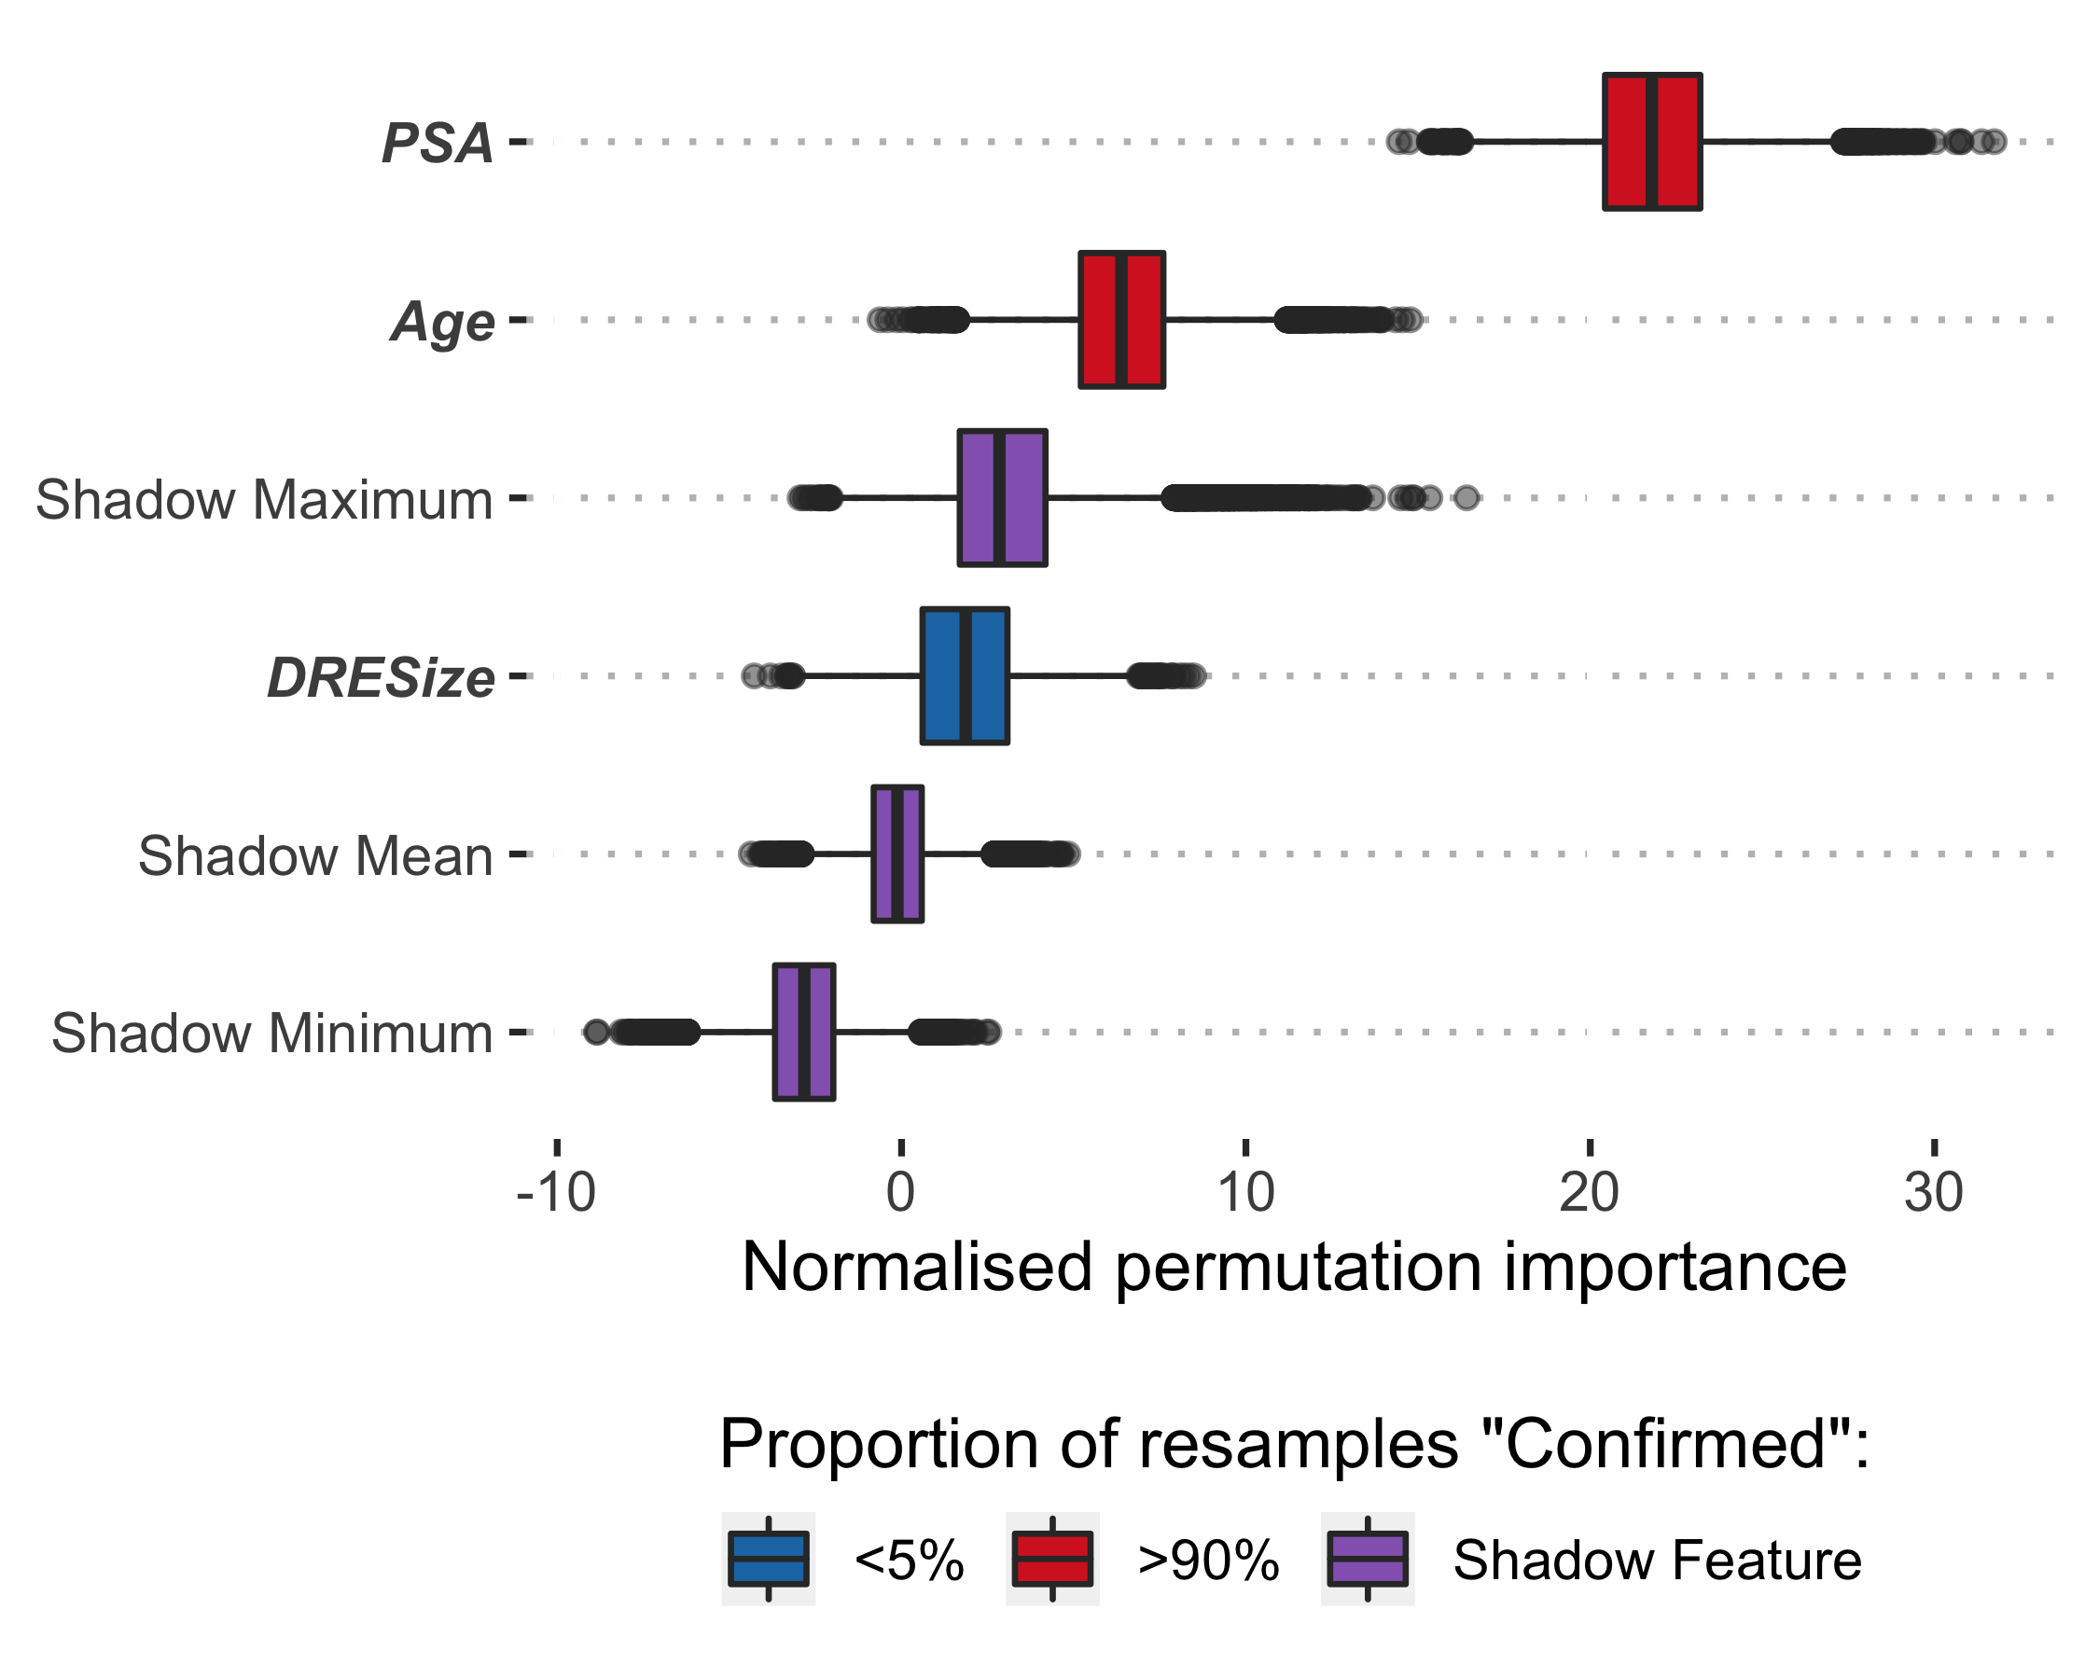

**Supplementary Figure 1.** *Boruta analysis of variables available for the training of the SoC model. Variable importance was determined over 1,000 bootstrap resamples of the available data and the decision reached recorded at each resample. Variable origins are denoted by font; clinical variables are italicised and emboldened. Colour indicates the proportion of the 1,000 resamples a variable was confirmed to be important in. Variables confirmed in at least 90% of resamples were selected for training predictive models.*

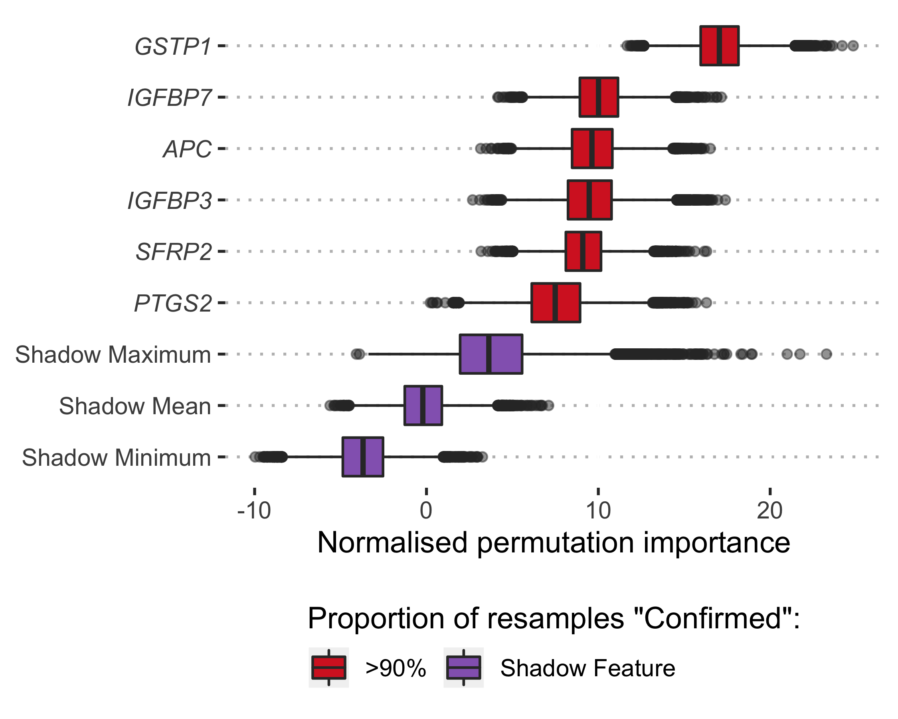

**Supplementary Figure 2.** *Boruta analysis of variables available for the training of the Methylation model. Variable importance was determined over 1,000 bootstrap resamples of the available data and the decision reached recorded at each resample. Variable origins are denoted by font; methylation variables are italicised. Colour indicates the proportion of the 1,000 resamples a variable was confirmed to be important in. Variables confirmed in at least 90% of resamples were selected for training predictive models.*

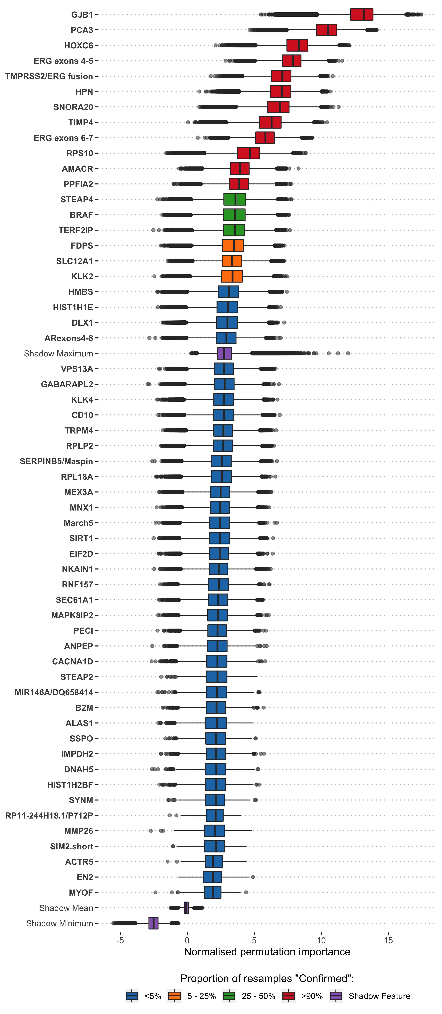

**Supplementary Figure 3.** *Boruta analysis of variables available for the training of the ExoRNA model. Variable importance was determined over 1,000 bootstrap resamples of the available data and the decision reached recorded at each resample. Variable origins are denoted by font; clinical variables are emboldened. Colour indicates the proportion of the 1,000 resamples a variable was confirmed to be important in. Variables confirmed in at least 90% of resamples were selected for training predictive models. Those variables rejected in every single resample are not shown here, but the full list of inputs for the ExoRNA model can be seen in Supplementary Table 1*

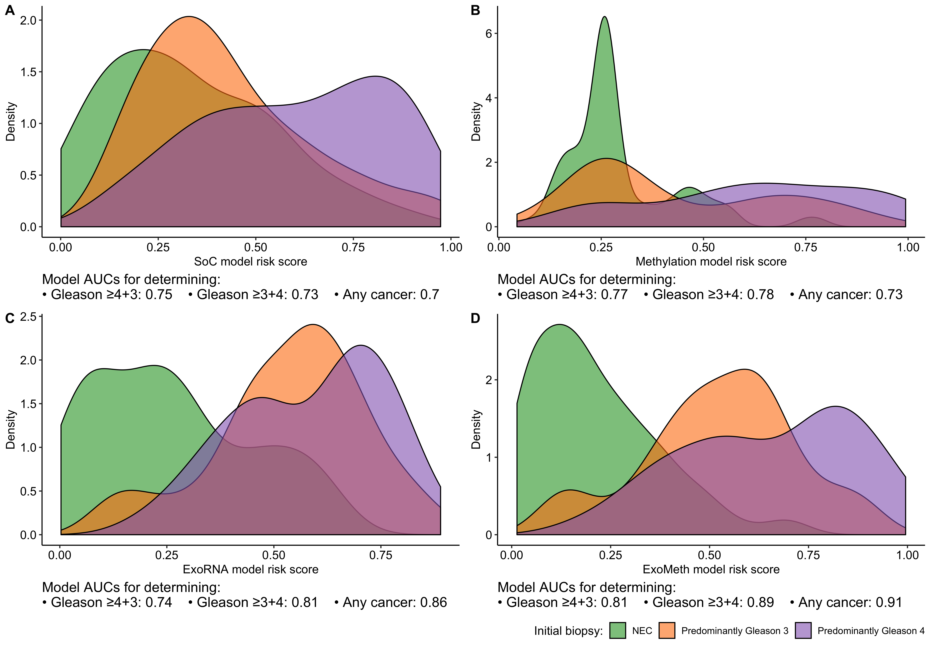

**Supplementary Figure 4.** *Density plots detailing risk score distributions generated from four trained models. Models A to D were trained with different input variables;* ***A*** *- SoC clinical risk model, including Age and PSA,* ***B*** *- Methylation model,* ***C*** *-ExoRNA model and* ***D*** *- ExoMeth model, combining the predictors from all three previous models. The full list of variables in each model is available in Table 1. Fill colour shows the risk score distribution of patients with with respect to biopsy outcome: No evidence of cancer (Blue), Gleason 6 or 3+4 (Orange), Gleason ≥ 4+3 (Green).*

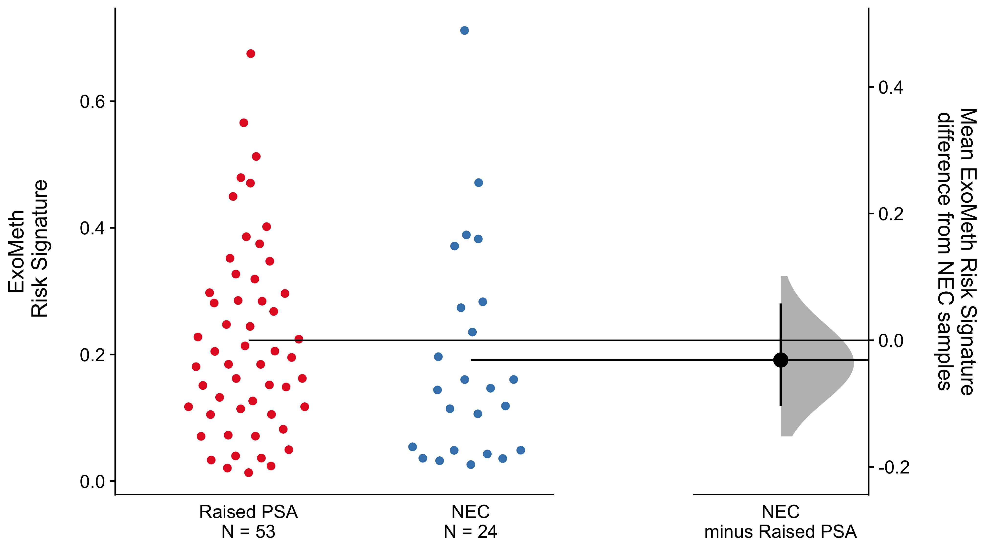

**Supplementary Figure 5** *Cumming estimation plot of the ExoMeth risk signatures in No evidence of cancer (NEC) and raised PSA, negative biopsy samples. The left panel details individual patients as points with ExoMeth risk score on the y-axis. Points are coloured according to clinical risk category; NEC - No evidence of cancer, Raised PSA - Raised PSA with negative biopsy. The right panel shows the mean differences in risk score between each NEC and Raised PSA samples. Mean differences and 95% confidence interval are displayed as a point estimate and vertical bar respectively, using the sample density distributions calculated from a bias-corrected and accelerated bootstrap analysis from 1,000 resamples.*

**Supplementary Table 1.** *List of all features available for selection as input variables for each model prior to boostrapped Boruta feature selection.*

|  |  |  |  |
| --- | --- | --- | --- |
| SoC | Methylation | ExoRNA | ExoMeth |
| PSA | GSTP1 | March5 | PSA |
| UrineVol | APC | AATF | UrineVol |
| DRESize | SFRP2 | ABCB9 | DRESize |
| Age | IGFBP3 | ACTR5 | Age |
|  | IGFBP7 | AGR2 | GSTP1 |
|  | PTGS2 | ALAS1 | APC |
|  |  | AMACR | SFRP2 |
|  |  | AMH | IGFBP3 |
|  |  | ANKRD34B | IGFBP7 |
|  |  | ANPEP | PTGS2 |
|  |  | APOC1 | March5 |
|  |  | ARexon9 | AATF |
|  |  | ARexons4-8 | ABCB9 |
|  |  | ARHGEF25 | ACTR5 |
|  |  | AURKA | AGR2 |
|  |  | B2M | ALAS1 |
|  |  | B4GALNT4 | AMACR |
|  |  | BRAF | AMH |
|  |  | BTG2 | ANKRD34B |
|  |  | CACNA1D | ANPEP |
|  |  | CADPS | APOC1 |
|  |  | CAMK2N2 | ARexon9 |
|  |  | CAMKK2 | ARexons4-8 |
|  |  | CASKIN1 | ARHGEF25 |
|  |  | CCDC88B | AURKA |
|  |  | CD10 | B2M |
|  |  | CDC20 | B4GALNT4 |
|  |  | CDC37L1 | BRAF |
|  |  | CDKN3 | BTG2 |
|  |  | CKAP2L | CACNA1D |
|  |  | CLIC2 | CADPS |
|  |  | CLU | CAMK2N2 |
|  |  | COL10A1 | CAMKK2 |
|  |  | COL9A2 | CASKIN1 |
|  |  | CP | CCDC88B |
|  |  | CTA-211A9.5/MIATNB | CD10 |
|  |  | DLX1 | CDC20 |
|  |  | DNAH5 | CDC37L1 |
|  |  | DPP4 | CDKN3 |
|  |  | EIF2D | CKAP2L |
|  |  | EN2 | CLIC2 |
|  |  | ERG exons 4-5 | CLU |
|  |  | ERG exons 6-7 | COL10A1 |
|  |  | ERG5 | COL9A2 |
|  |  | FDPS | CP |
|  |  | FOLH1/PSMA/NAALAD1 | CTA-211A9.5/MIATNB |
|  |  | GABARAPL2 | DLX1 |
|  |  | GAPDH | DNAH5 |
|  |  | GCNT1 | DPP4 |
|  |  | GJB1 | EIF2D |
|  |  | GOLM1 | EN2 |
|  |  | HIST1H1C | ERG exons 4-5 |
|  |  | HIST1H1E | ERG exons 6-7 |
|  |  | HIST1H2BF | ERG5 |
|  |  | HIST1H2BG | FDPS |
|  |  | HIST32HA | FOLH1/PSMA/NAALAD1 |
|  |  | HMBS | GABARAPL2 |
|  |  | HOXC4 | GAPDH |
|  |  | HOXC6 | GCNT1 |
|  |  | HPN | GJB1 |
|  |  | HPRT | GOLM1 |
|  |  | IFT57 | HIST1H1C |
|  |  | IGFBP3 | HIST1H1E |
|  |  | IMPDH2 | HIST1H2BF |
|  |  | ISX | HIST1H2BG |
|  |  | ITGBL1 | HIST32HA |
|  |  | ITPR1 | HMBS |
|  |  | KLK2 | HOXC4 |
|  |  | KLK3/PSA(exons1-2 | HOXC6 |
|  |  | KLK3/PSA(exons2-3 | HPN |
|  |  | KLK4 | HPRT |
|  |  | LASS1 | IFT57 |
|  |  | LBH | IGFBP3 |
|  |  | MAK | IMPDH2 |
|  |  | MAPK8IP2 | ISX |
|  |  | MCM7 | ITGBL1 |
|  |  | MCTP1 | ITPR1 |
|  |  | MDK | KLK2 |
|  |  | MED4 | KLK3/PSA(exons1-2 |
|  |  | MEMO1 | KLK3/PSA(exons2-3 |
|  |  | Met | KLK4 |
|  |  | MEX3A | LASS1 |
|  |  | MFSD2A | LBH |
|  |  | MGAT5B | MAK |
|  |  | MIC1 | MAPK8IP2 |
|  |  | MIR146A/DQ658414 | MCM7 |
|  |  | MIR4435-1HG/lOC541471 | MCTP1 |
|  |  | MKi67 | MDK |
|  |  | MMP11 | MED4 |
|  |  | MMP25 | MEMO1 |
|  |  | MMP26 | Met |
|  |  | MNX1 | MEX3A |
|  |  | MSMB | MFSD2A |
|  |  | MXI1 | MGAT5B |
|  |  | MYOF | MIC1 |
|  |  | NAALADL2 | MIR146A/DQ658414 |
|  |  | NEAT1 | MIR4435-1HG/lOC541471 |
|  |  | NKAIN1 | MKi67 |
|  |  | NLRP3 | MMP11 |
|  |  | OGT | MMP25 |
|  |  | OR52A2/PSGR | MMP26 |
|  |  | PALM3 | MNX1 |
|  |  | PCA3 | MSMB |
|  |  | PCSK6 | MXI1 |
|  |  | PDLIM5 | MYOF |
|  |  | PECI | NAALADL2 |
|  |  | PPAP2A | NEAT1 |
|  |  | PPFIA2 | NKAIN1 |
|  |  | PPP1R12B | NLRP3 |
|  |  | PSTPIP1 | OGT |
|  |  | PTN | OR52A2/PSGR |
|  |  | PTPRC | PALM3 |
|  |  | PVT1 | PCA3 |
|  |  | RAB17 | PCSK6 |
|  |  | RIOK3 | PDLIM5 |
|  |  | RNF157 | PECI |
|  |  | RP11-244H18.1/P712P | PPAP2A |
|  |  | RP11-97O12.7 | PPFIA2 |
|  |  | RPL18A | PPP1R12B |
|  |  | RPL23AP53 | PSTPIP1 |
|  |  | RPLP2 | PTN |
|  |  | RPS10 | PTPRC |
|  |  | RPS11 | PVT1 |
|  |  | SACM1L | RAB17 |
|  |  | SChLAP1 | RIOK3 |
|  |  | SEC61A1 | RNF157 |
|  |  | SERPINB5/Maspin | RP11-244H18.1/P712P |
|  |  | SFRP4 | RP11-97O12.7 |
|  |  | SIM2.long | RPL18A |
|  |  | SIM2.short | RPL23AP53 |
|  |  | SIRT1 | RPLP2 |
|  |  | SLC12A1 | RPS10 |
|  |  | SLC43A1 | RPS11 |
|  |  | SLC4A1 S | SACM1L |
|  |  | SMAP1 ex 7-8 | SChLAP1 |
|  |  | SMIM1 | SEC61A1 |
|  |  | SNCA | SERPINB5/Maspin |
|  |  | SNORA20 | SFRP4 |
|  |  | SPINK1 | SIM2.long |
|  |  | SPON2 | SIM2.short |
|  |  | SRSF3 | SIRT1 |
|  |  | SSPO | SLC12A1 |
|  |  | SSTR1 | SLC43A1 |
|  |  | ST6GALNAC1 | SLC4A1 S |
|  |  | STEAP2 | SMAP1 ex 7-8 |
|  |  | STEAP4 | SMIM1 |
|  |  | STOM | SNCA |
|  |  | SULF2 | SNORA20 |
|  |  | SULT1A1 | SPINK1 |
|  |  | SYNM | SPON2 |
|  |  | TBP | SRSF3 |
|  |  | TDRD | SSPO |
|  |  | TERF2IP | SSTR1 |
|  |  | TERT | ST6GALNAC1 |
|  |  | TFDP1 | STEAP2 |
|  |  | TIMP4 | STEAP4 |
|  |  | TMCC2 | STOM |
|  |  | TMEM45B | SULF2 |
|  |  | TMEM47 | SULT1A1 |
|  |  | TMEM86A | SYNM |
|  |  | TMPRSS2/ERG fusion | TBP |
|  |  | TRPM4 | TDRD |
|  |  | TWIST1 | TERF2IP |
|  |  | UPK2 | TERT |
|  |  | VAX2 | TFDP1 |
|  |  | VPS13A | TIMP4 |
|  |  | ZNF577 | TMCC2 |
|  |  |  | TMEM45B |
|  |  |  | TMEM47 |
|  |  |  | TMEM86A |
|  |  |  | TMPRSS2/ERG fusion |
|  |  |  | TRPM4 |
|  |  |  | TWIST1 |
|  |  |  | UPK2 |
|  |  |  | VAX2 |
|  |  |  | VPS13A |
|  |  |  | ZNF577 |

# References

1. R Core Team. R: A Language and Environment for Statistical Computing [Internet]. Vienna, Austria: R Foundation for Statistical Computing; 2019. Available from: <https://www.r-project.org/>

2. Guyon I, Elisseeff A. An introduction to variable and feature selection. Journal of machine learning research. 2003;3(Mar):1157–82.

3. Kursa MB, Rudnicki WR. Feature Selection with the Boruta Package. Journal of Statistical Software. 2010;36(11).

4. Breiman L. Random forests. Machine Learning [Internet]. 2001;45(1):5–32. Available from: <http://link.springer.com/10.1023/A:1010933404324>

5. Liaw A, Wiener M. Classification and regression by randomForest. R News [Internet]. 2002;2(3):18–22. Available from: <https://CRAN.R-project.org/doc/Rnews/>

6. Robin X, Turck N, Hainard A, Tiberti N, Lisacek F, Sanchez J-C, et al. PROC: An open-source package for r and s+ to analyze and compare roc curves. BMC Bioinformatics. 2011;12:77.

7. Wickham H. Ggplot2: Elegant graphics for data analysis [Internet]. Springer-Verlag New York; 2016. Available from: <https://ggplot2.tidyverse.org>

8. Ho J, Tumkaya T, Aryal S, Choi H, Claridge-Chang A. Moving beyond P values: data analysis with estimation graphics. Nature Methods [Internet]. 2019 Jun;1. Available from: <http://www.nature.com/articles/s41592-019-0470-3>

9. Vickers AJ, Elkin EB. Decision Curve Analysis: A Novel Method for Evaluating Prediction Models. Medical Decision Making [Internet]. 2006;26(6):565–74. Available from: <http://journals.sagepub.com/doi/10.1177/0272989X06295361>

10. Brown M. rmda: Risk Model Decision Analysis [Internet]. 2018. Available from: <https://cran.r-project.org/package=rmda>

11. Kerr KF, Brown MD, Zhu K, Janes H. Assessing the clinical impact of risk prediction models with decision curves: Guidance for correct interpretation and appropriate use. Journal of Clinical Oncology [Internet]. 2016;34(21):2534–40. Available from: <www.jco.org>

12. Martin RM, Donovan JL, Turner EL, Metcalfe C, Young GJ, Walsh EI, et al. Effect of a low-intensity PSA-based screening intervention on prostate cancer mortality: The CAP randomized clinical trial. JAMA - Journal of the American Medical Association. 2018 Mar;319(9):883–95.

13. Martin RM, Donovan JL, Turner EL, Metcalfe C, Young GJ, Walsh EI, et al. Effect of a low-intensity PSA-based screening intervention on prostate cancer mortality: The CAP randomized clinical trial. JAMA - Journal of the American Medical Association [Internet]. 2018 Mar;319(9):883–95. Available from: <http://jama.jamanetwork.com/article.aspx?doi=10.1001/jama.2018.0154>